NEW ROCHELLE UNITED METHODIST MEN
2017 Men’s Day
&
Book Fair
Sunday, May 21st
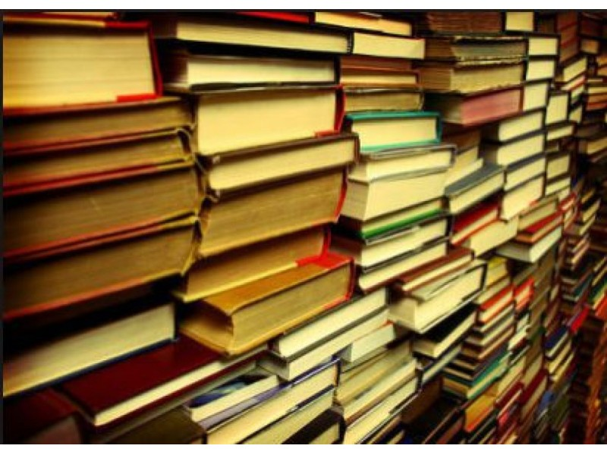

Guest Speaker: Reverend Lamont S. Granby

First Baptist Church-Bronxville, New York

SERVICE 10:30am
BOOK FAIR Immediately After Service

New Rochelle United Methodist Church

1200 North Avenue

New Rochelle, New York 10804

http://www.gcumm.org/groups/NRUMM
Ed Gooding, Sr.
914.819.8528
EdGGTINC@hotmail.com

